**Experiment 1.4**

**Student Name:** Sahil Kaundal **UID:** 21BCS8197

**Branch:** BE CSE (Lateral Entry) **Section/Group:** 807/B

**Semester:** 4th **Date of Performance:** 16/03/2022

**Subject Name:** MPI Lab **Subject Code:** 22E-20CSP-253

**1. Aim/Overview of the practical:**

Complement of a number 8 bit data.

**2. Task to be done/ Which logistics used:**

1’s Complement of a number 8 bit data using Jubin Application.

2’s Complement of a number 8 bit data using Jubin Application.

**3. Apparatus / Simulator Used:**

1. Jubin Application

2. 8085 Simulator

3. JDK

**4. Algorithms:**

**1’s Complement:**

1. Load H – L pair with address 1000H.

2. Complement Accumulator.

3. Store the result at memory location 1050H.

4. Terminate the program.

**2’s Complement:**

1. Load H – L pair with address 1000H.

2. Complement Accumulator.

3. Store the result at memory location 1050H.

4. Increase Accumulator by 1.

5. Store the memory location 1051H.

6. Terminate the program.

**5. Programs:**

**1’s Complement:**

LDA 1000H

CMA

STA 1050H

HLT

**2’s Complement:**

LDA 1000H

CMA

STA 1050H

INR A

STA 1051H

HLT

**6. Result/Output/Writing Summary:**

**1’s Complement:**

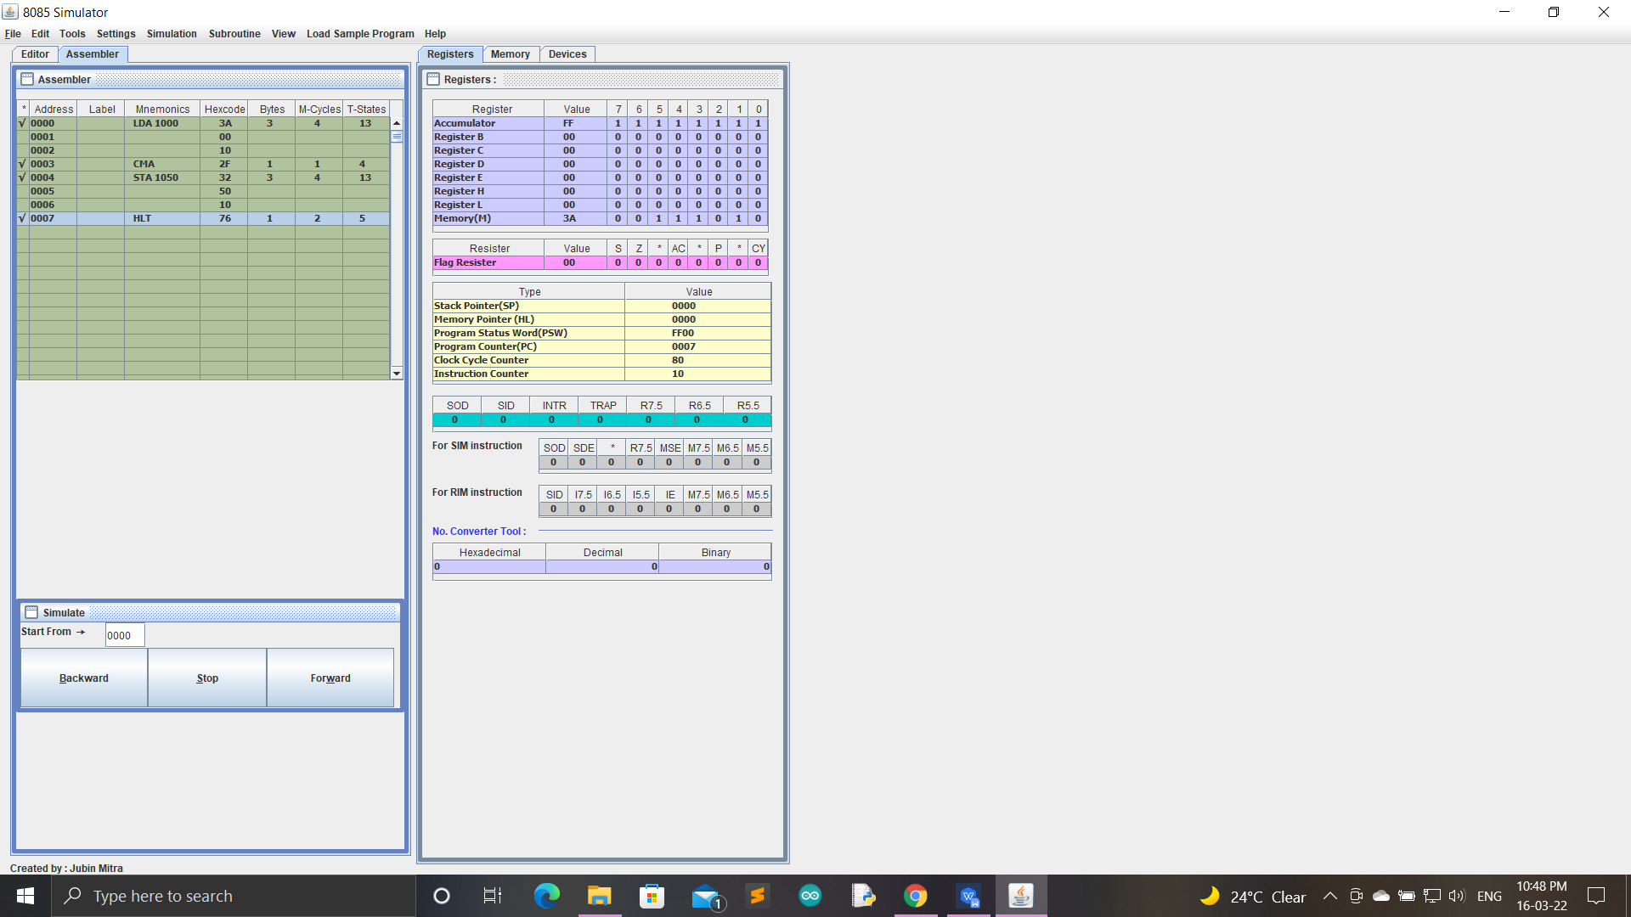

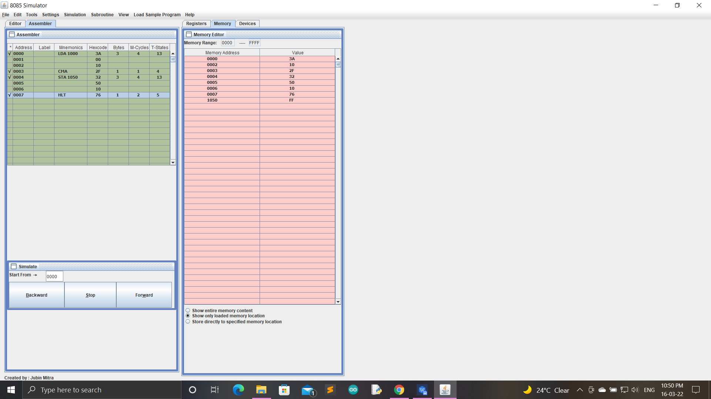

**2’s Complement:**

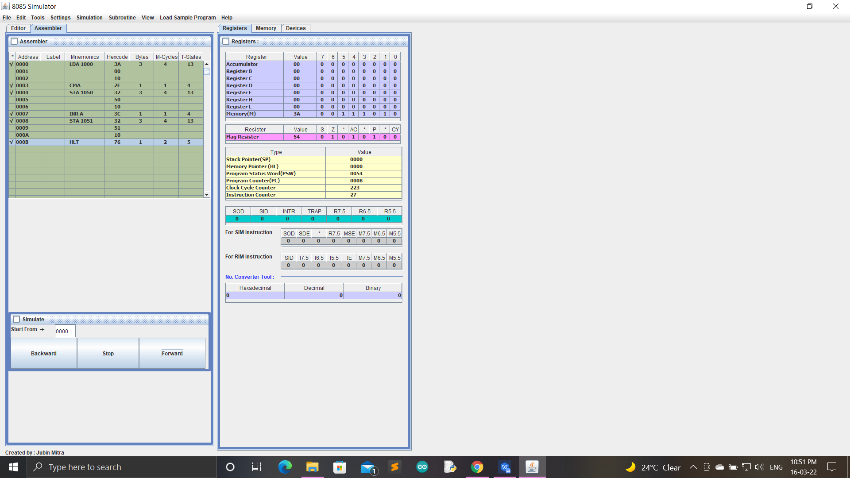

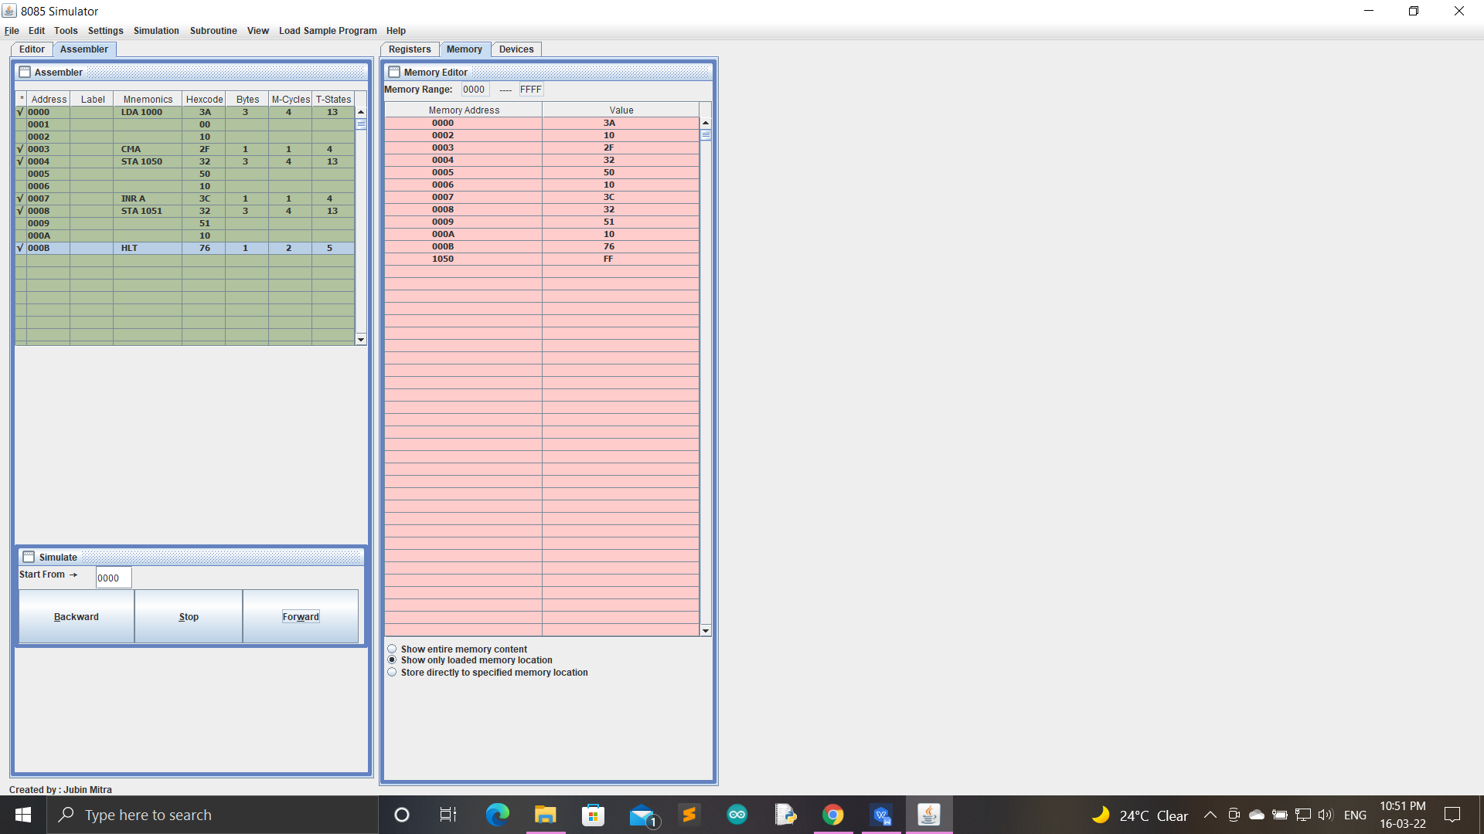

**Learning outcomes (What I have learnt):**

1. Working of microprocessors.

2. Learn how to complement data in microprocessors.

3. Learn about 8085 simulator.

4. Operations of 8 bit numbers.

5. Learn about the different instructions that are needed to be given to the memory to perform some tasks.

**Evaluation Grid (To be created as per the SOP and Assessment guidelines by the faculty):**

|  |  |  |  |
| --- | --- | --- | --- |
| Sr. No. | Parameters | Marks Obtained | Maximum Marks |
| 1. |  |  |  |
| 2. |  |  |  |
| 3. |  |  |  |
|  |  |  |  |